TELA DE BUSCA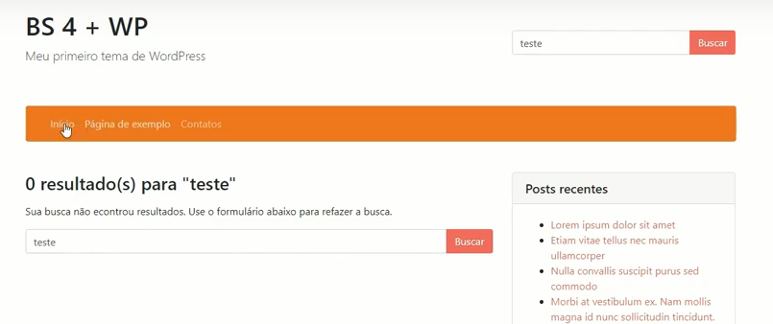

<?php get_header(); ?>

<div class="row">

<div class="col-md-8 col-sm-12">

<?php

// Se houver resultados exibe o conteúdo, se não exibe um formuládio de buscas

if (is_search()) :

$total_results = $wp_query->found_posts;

echo "<h3 class='mb-3'>" . sprintf( __('%s resultado(s) para "%s"','BS 4 + WP'), $total_results, get_search_query()) . "</h3>";

endif;

?>

<?php if(have_posts()) : while(have_posts()) : the_post(); ?>

<div class="blog-post">

<h3 class="mb-3 pb-2 border-bottom"><a href="<?php the_permalink(); ?>"><?php the_title(); ?></a></h3>

<div class="row">

<div class="col-md-12 col-lg-6 mb-3">

<a href="<?php the_permalink(); ?>">

<?php the_post_thumbnail('post-thumbnail', array('class' => 'img-fluid')); ?>

</a>

</div>

<div class="col-md-12 col-lg-6 mb-3">

<?php the_excerpt(); ?>

</div>

</div>

<p class="text-muted">Publicado em: <span class="badge badge-my-color-4"><?php echo get_the_date('d/m/y'); ?></span></p>

</div>

<?php endwhile; ?>

<?php else :

echo "<p>Sua busca não econtrou resultados. Use o formulário abaixo para refazer a busca.</p>";

get_search_form();

endif; ?>

<div class="blog-pagination mb-5">

<?php next_posts_link( 'Mais antigos' ); ?> <?php previous_posts_link( 'Mais novos' ); ?>

</div>

</div>

<?php get_sidebar(); ?>

</div>

</div>

<?php get_footer(); ?>

Para ter somente post insira esse codigo

